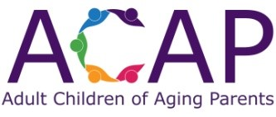

Program Sponsorship Commitment – ACAP (chapter name)
Please print

Name of Business/Organization: ________________________________________________________________

Name & title of person authorizing sponsorship: ___________________________________________________

Mailing address of business/organization: ________________________________________________________

Phone: ____________________________ Email: __________________________________________________

Sponsorship Commitment
( ) We agree to provide $100.00 per sponsored month plus assist with providing light refreshments for
attendees of the sponsored program (Note: Anticipated number of attendees will be provided 1 week prior
to the program, with updates as appropriate.)

Commitment / Payment / Pledge
( ) We wish to sponsor a total of (#) ____ month/months of 2022 ACAP _______: Total $________
( ) Enclosed, please find payment for (#)________ month(s) of sponsorship: Total $________
( ) Future payment will be made for (#) ________ month(s) of sponsorship: Total $________
Payment is due by the 1st day of the month preceding the sponsored month

Preferred month(s) for sponsorship

Month 1 ___________________________________________________

Month 2 ___________________________________________________

Month 3 ___________________________________________________

We have read and agree to adhere to ACAP’s Guiding Principles.

Authorized signature __________________________________________________________________________

Date _______________________________________________________________________________________

Please make checks payable to ACAPcommunity and mail to:
ACAPcommunity
PO Box 8278
Morganton, NC 28680

Thank you for your support of ACAP ______________!

